GAIRE ANANTA PRASAD

M24W0272

Data Insertion Interval

1. Knuth Shell Sort

Java Code

Output

Pseudocode

Flow-Chart

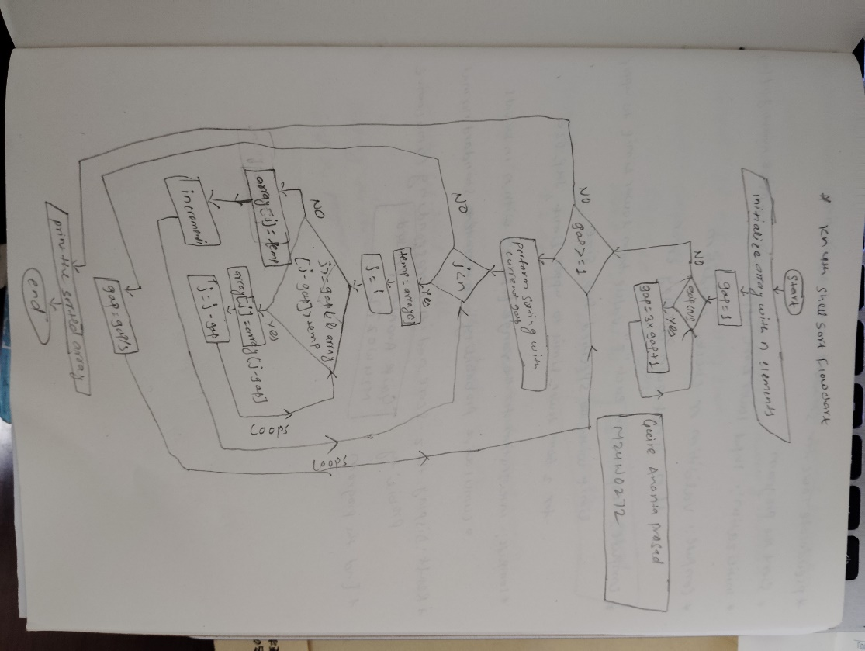

1. Hibbard Shell Sort

Java Code

Output

Pseudocode

Flow-Chart

1. Sedgewick Shell Sort

Java Code

Output

Pseudocode

Flow-Chart

